Step 1:
Go to command prompt
And write this command
C:\Users\Abhi>cd Desktop
So by writing this command the directory changes to desktop (cd is used for change directory)
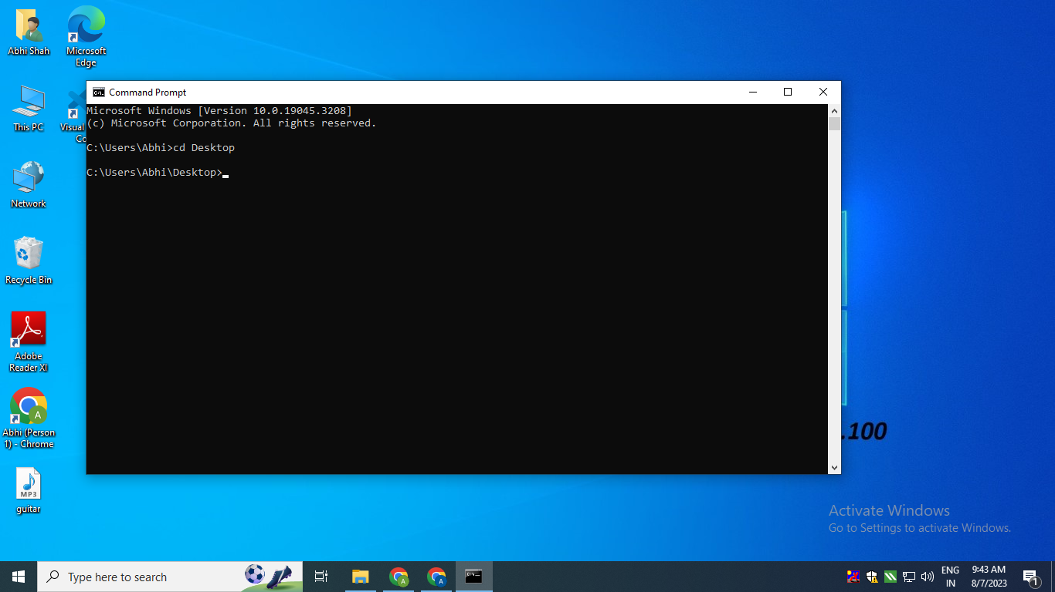
Step 2:
Prior to this command install python latest version if not installed or only anaconda is installed by going on this site:
https://www.python.org/downloads/release/python-3114/
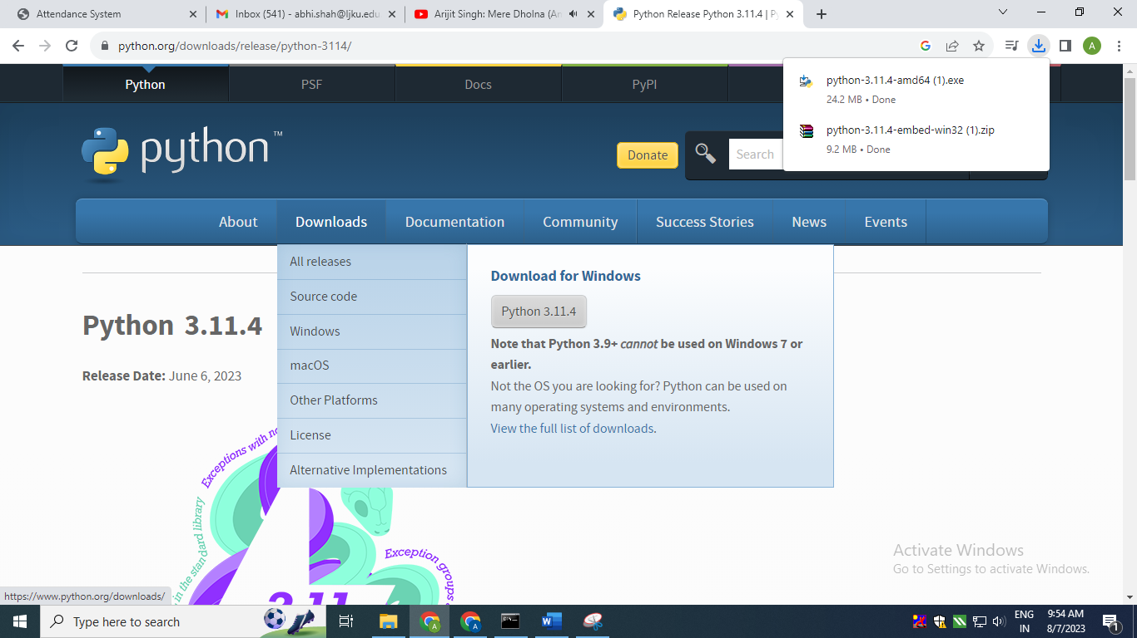
To create a virtual environment, write command
python -m venv envr
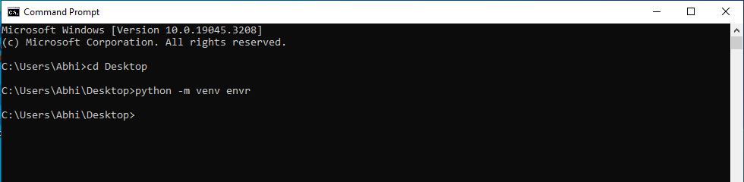
So, on desktop an icon will be formed with envr name (any name can be given to the virtual environment)
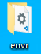
Step 3:
In order to activate the environment the following command needs to be written:
envr\scripts\activate
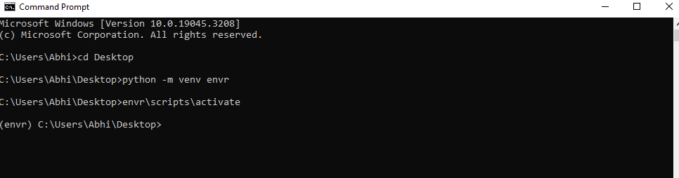
In order to activate the environment the following command needs to be written:
envr\scripts\deactivate
Step 4:
To install Django we need to write the following command: (As we are creating virtual environment and in that we need to install django so that we are not disturbing the another environment and we are working in virtual environment created so far i.e. django
pip install django
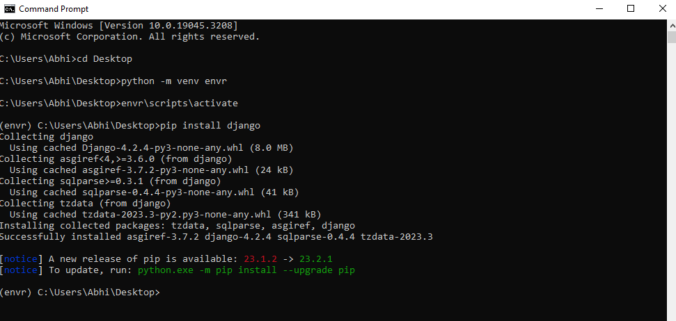
Use cls to clear the screen
Step 5:
Use django-admin to see a list of commands that you can run in django.
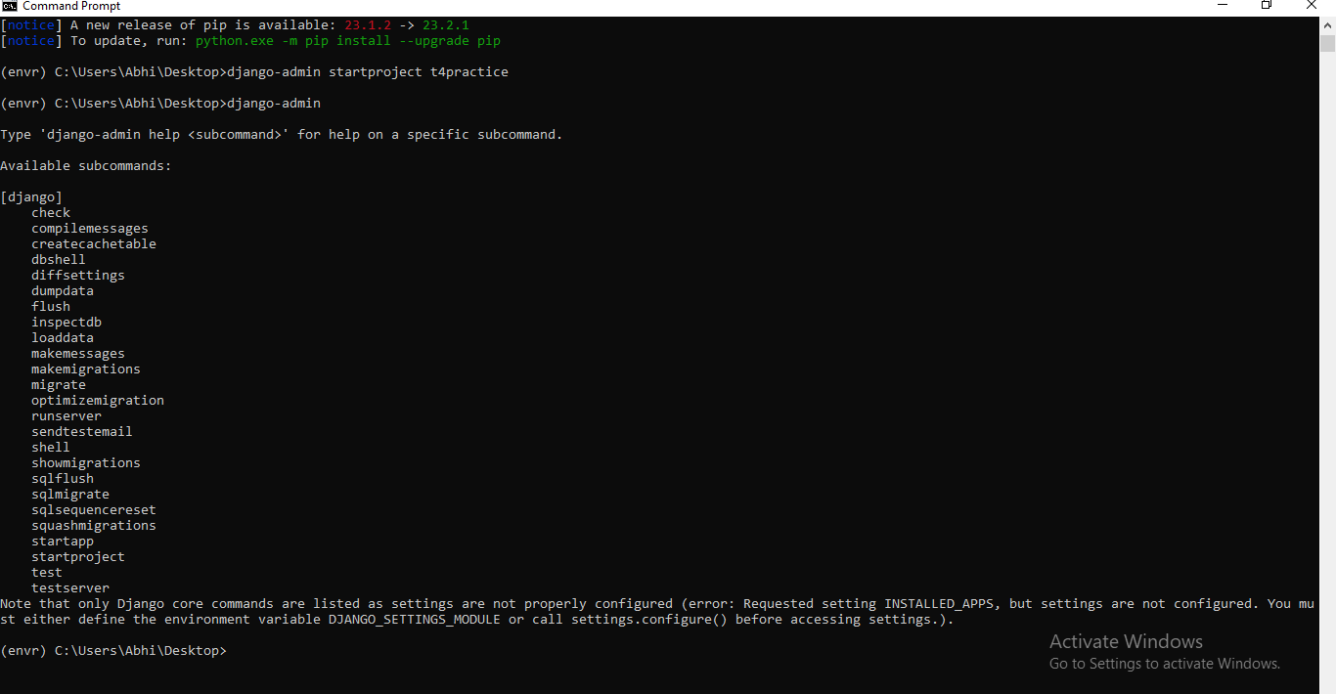
Step 6: To start a new project write this command below:
django-admin startproject t4practice
By entering this a new folder will be created on desktop i.e. a new project
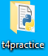
Step 7: To change directory to t4 practice write below command:
cd t4practice
Step 8: Write below command to run the django default site
python manage.py runserver
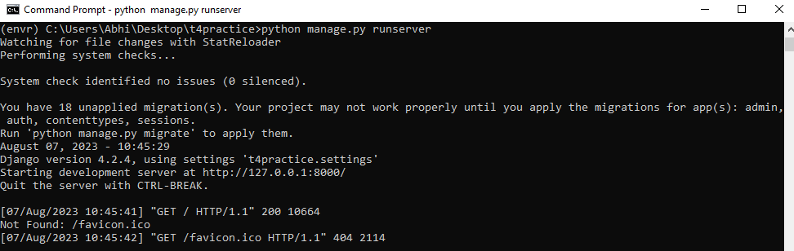
By clicking on site obtained by running in command window we get:
Site link: http://127.0.0.1:8000/
By clicking on this we get the output as:
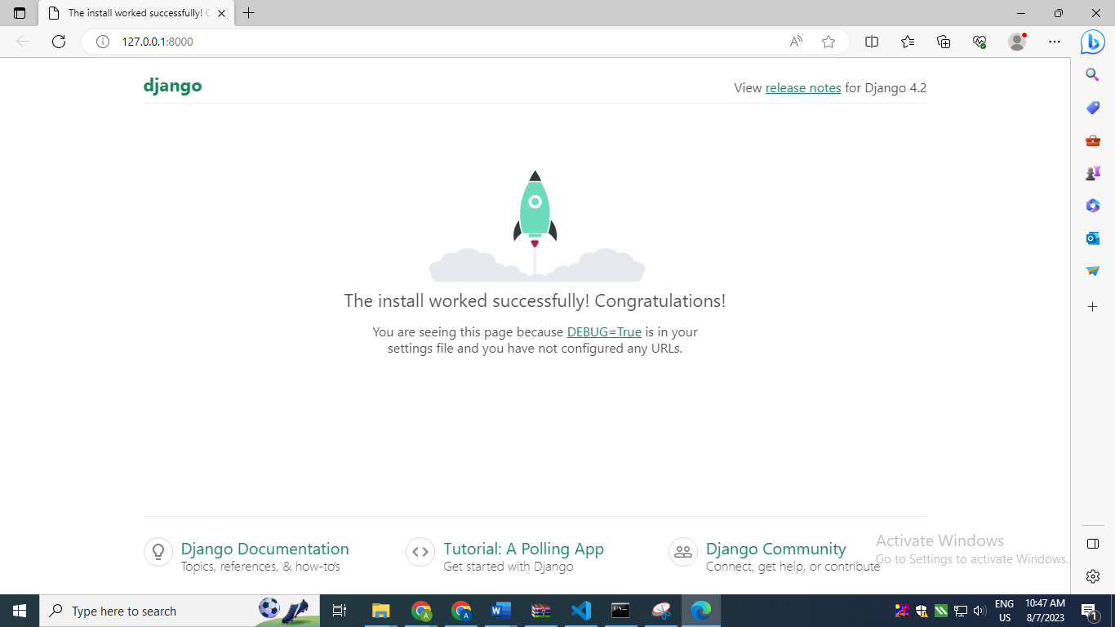

Step 9: Shift entire envr folder in t4practice folder so virtual environment can be operated from t4practice.
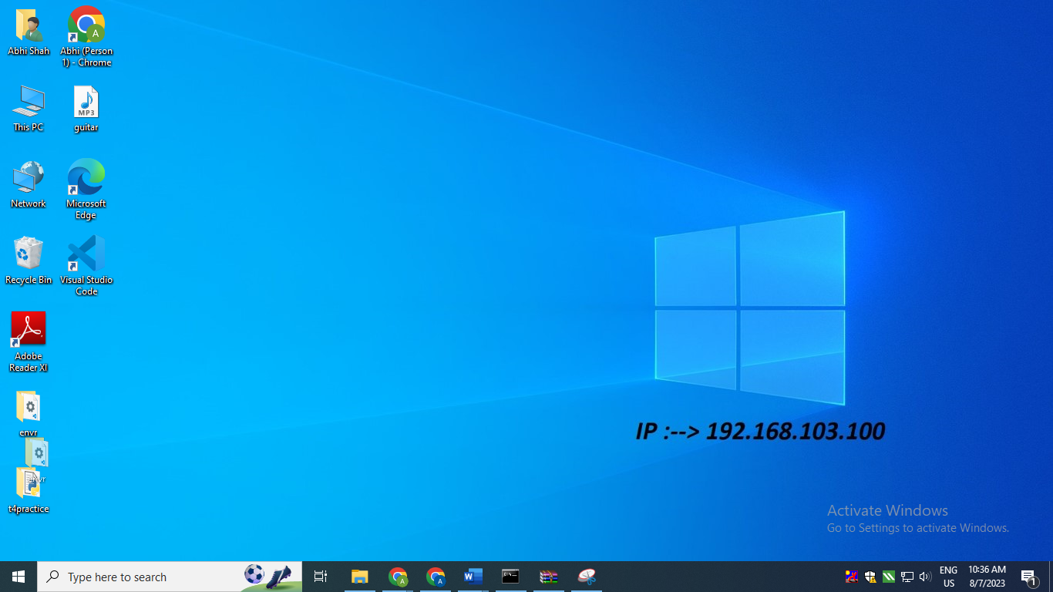
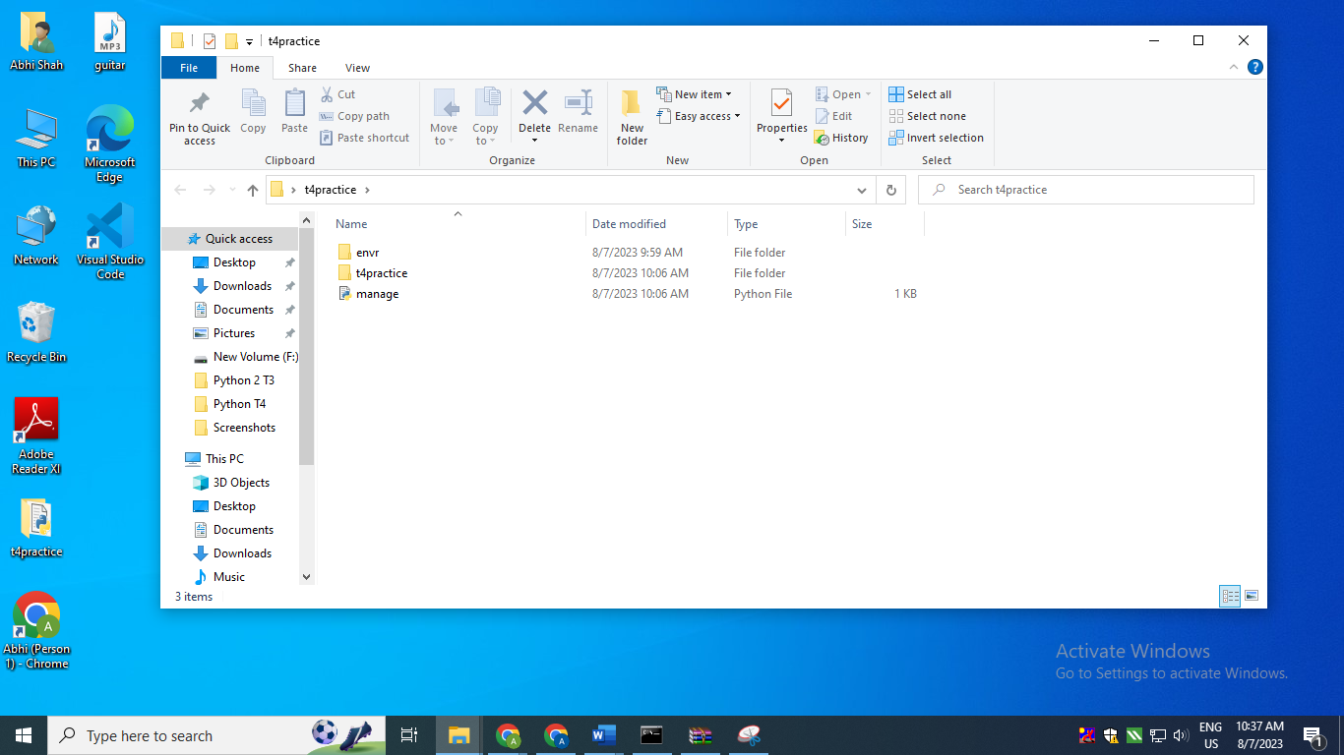
After this close the command prompt.
Step 10: Go to vs code and there go to file-> open folder-> t4practice
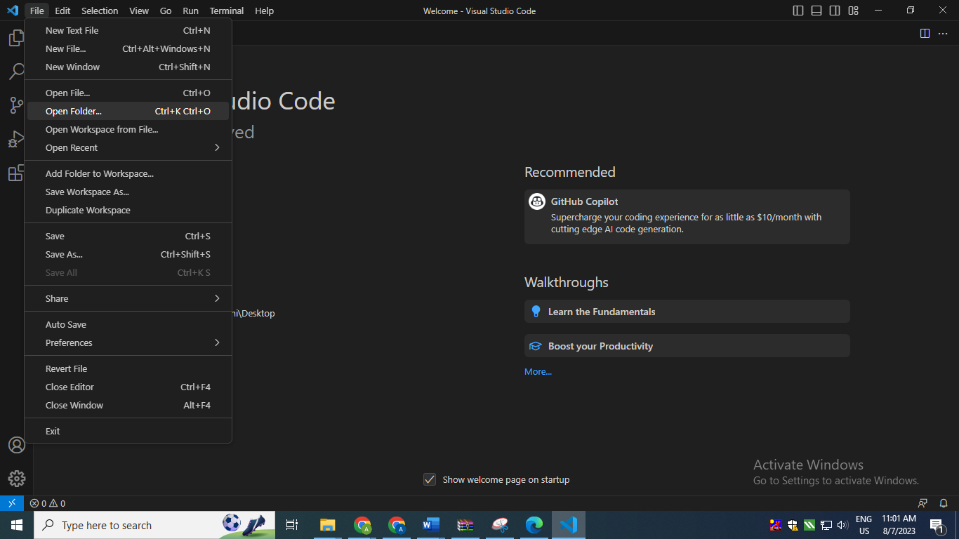
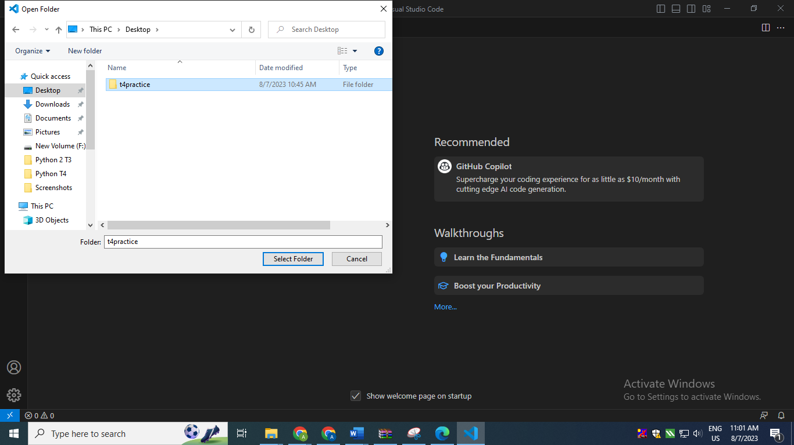
By clicking on that folder the window will come as below:
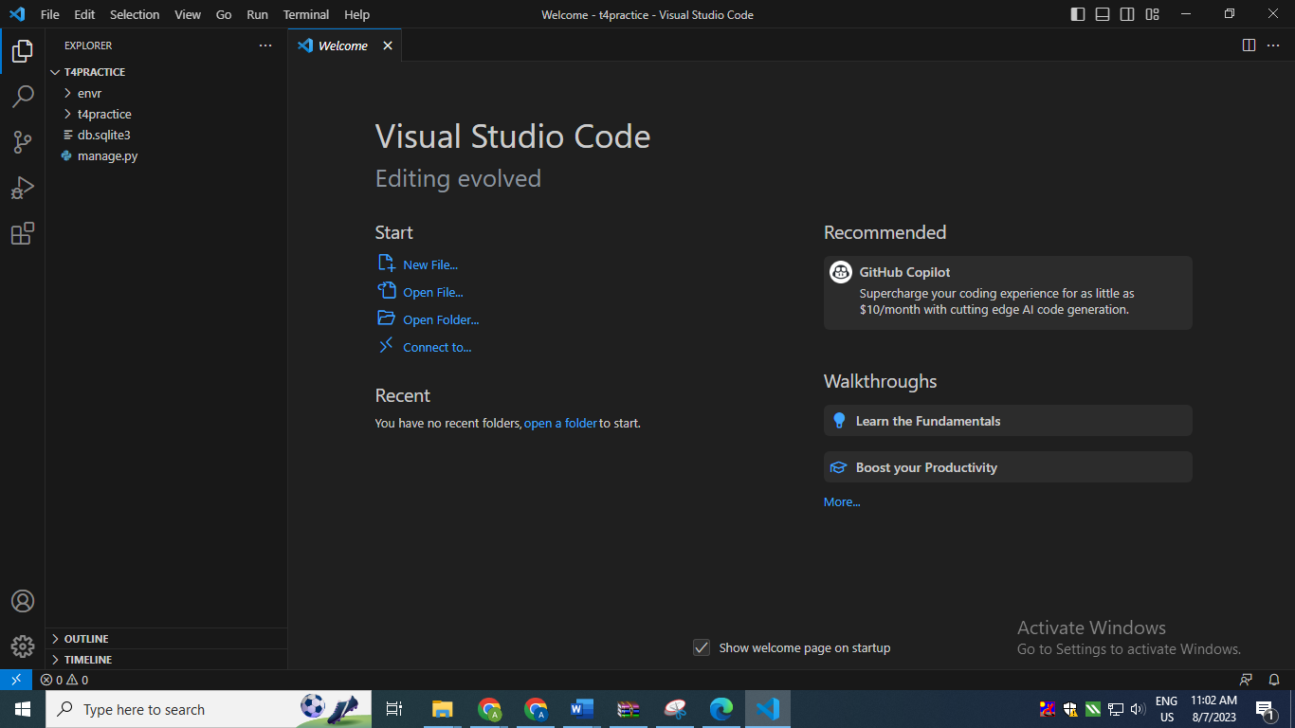
Step 11: Go to Terminal -> New Terminal
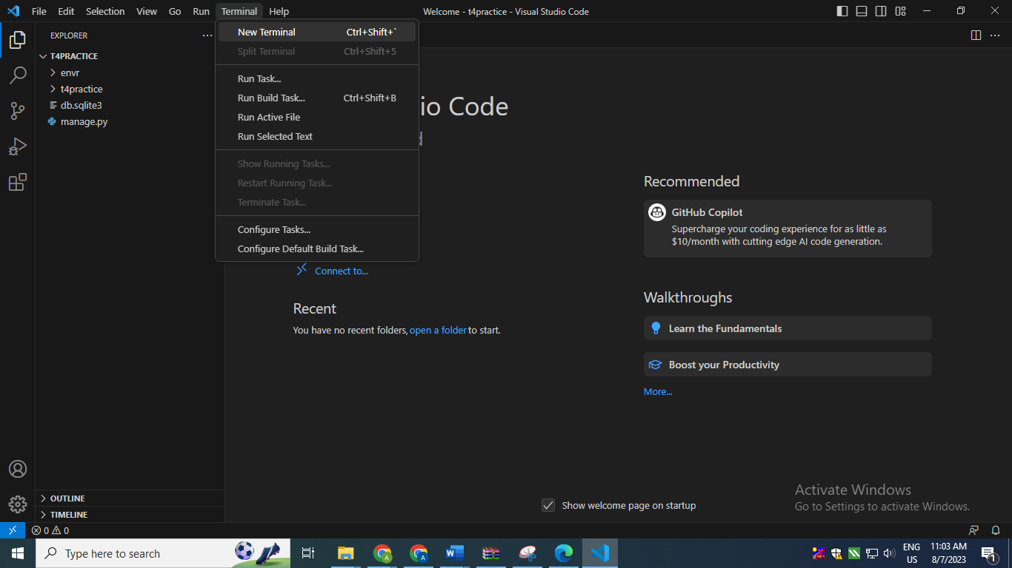
The below window will become as:
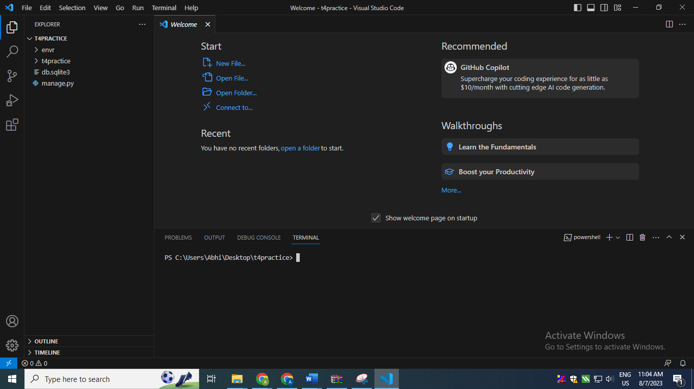
Then activate the envr which we copied into t4practice
If this error comes the go to
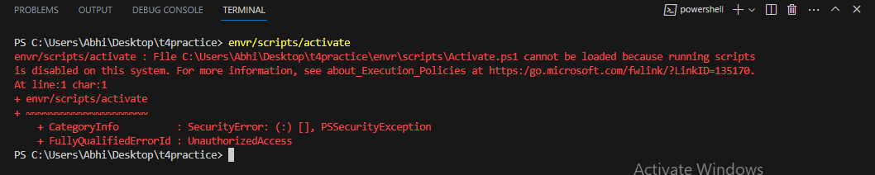
Windows powershell and right click on it and run as administrator:
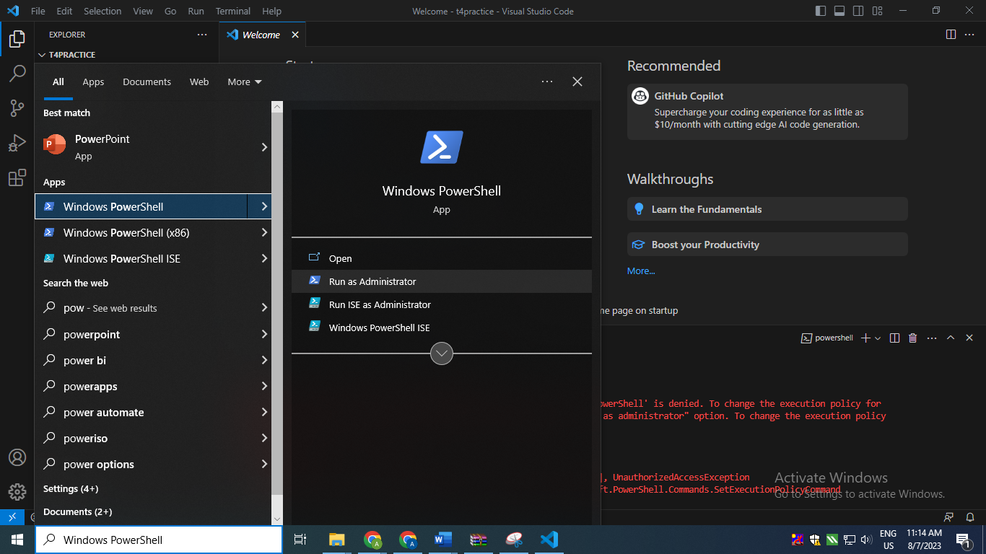
set-executionpolicy remotesigned
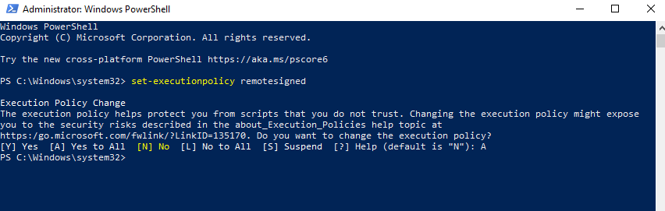
Then again write the command below:
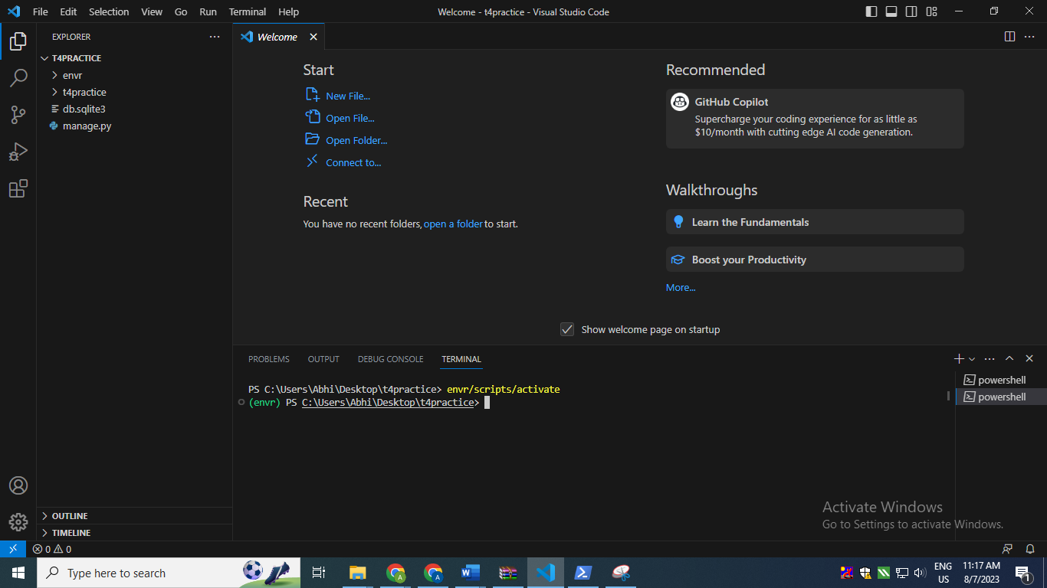
And again environment will be activated.
Again go to terminal -> new terminal again activate the environment and then write the following command:
python manage.py runserver
So one new terminal will be generated for running and the window will be as below with 18 unapplied migrations
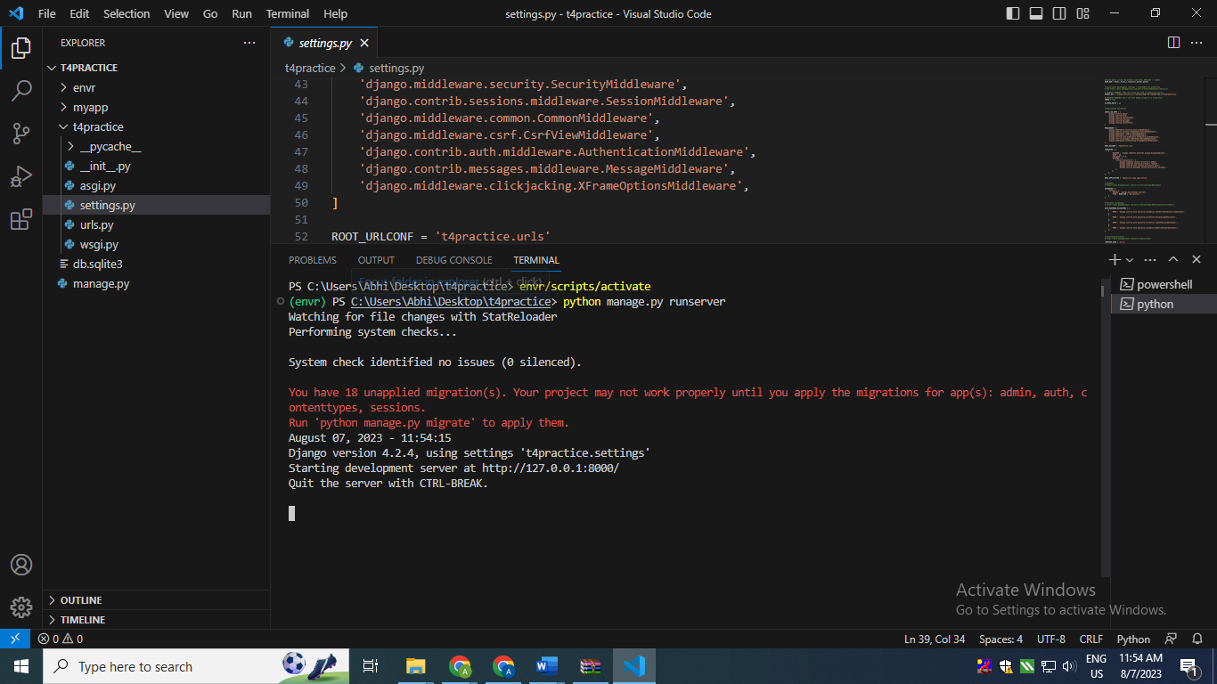
Step 12: To make a new app:
python manage.py startapp myapp
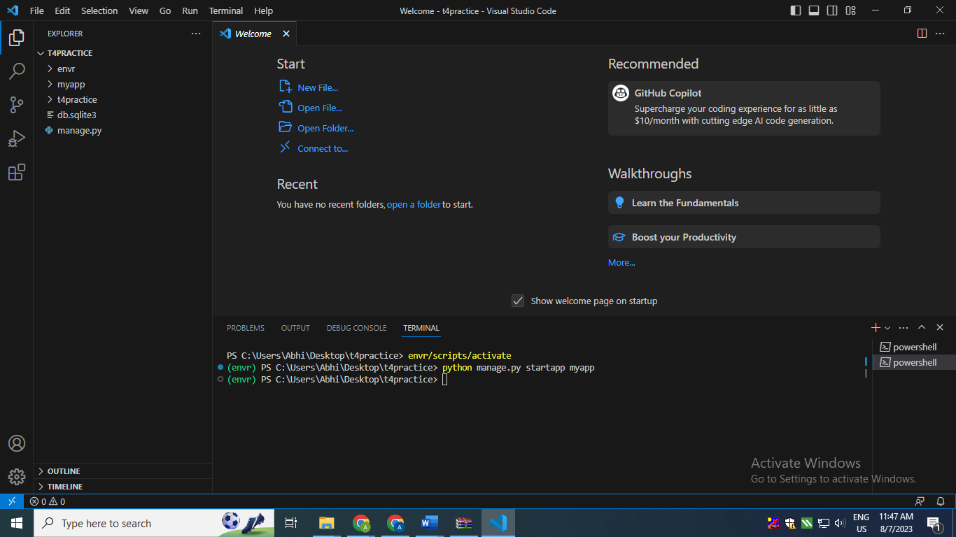
To visualize look into This PC-> Desktop -> t4practice in that myapp folder will be created.

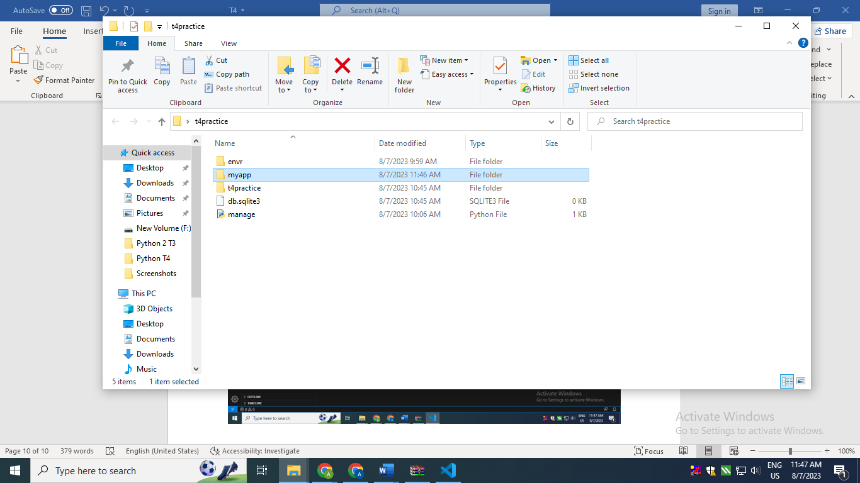
In order to register the new app made go to t4practice->settings.py
At this point, the project doesn’t know about the existence of the base app. So go to settings.py file in the project and add the app in the following way:

First go to myapp->apps.py see the class name as MyappConfig
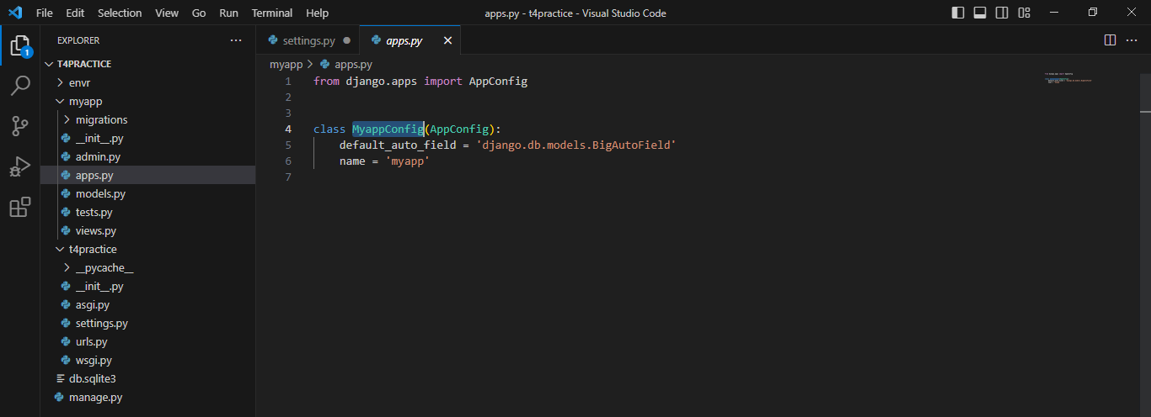
The window will appear as:
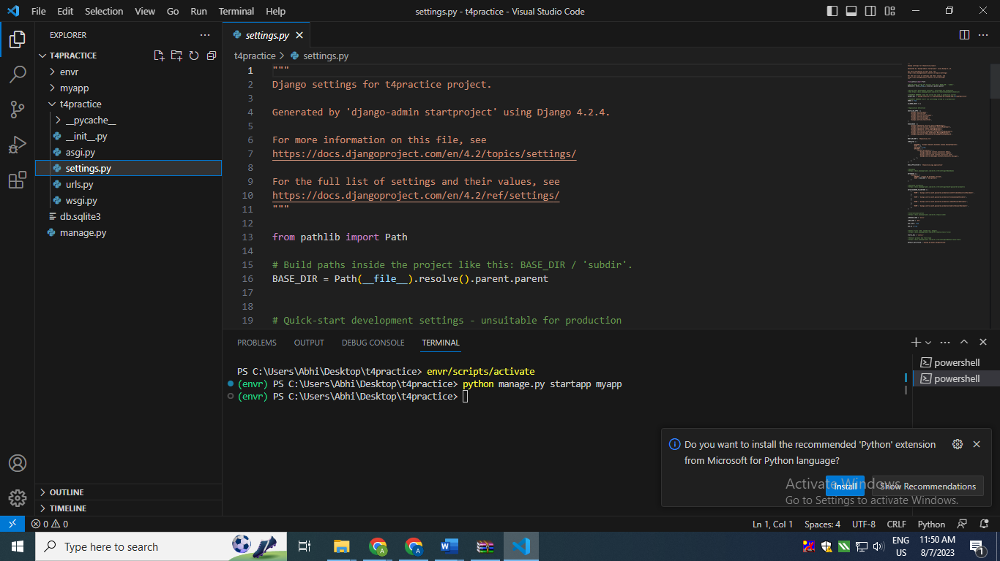
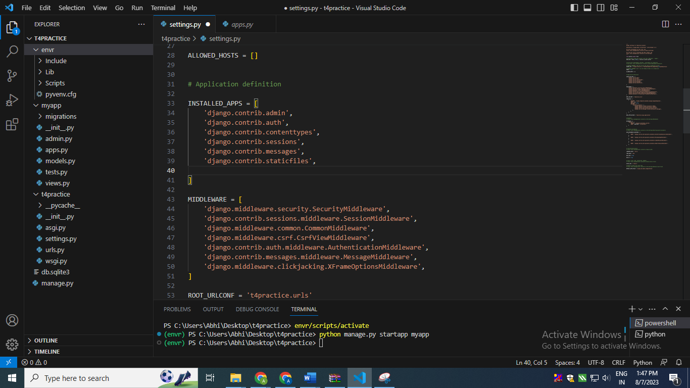

Go to INSTALLED_APPS and write this at last
myapp.apps.MyappConfig
Here myapp is the app and apps is from apps.py and MyappConfig is the class name from apps.py
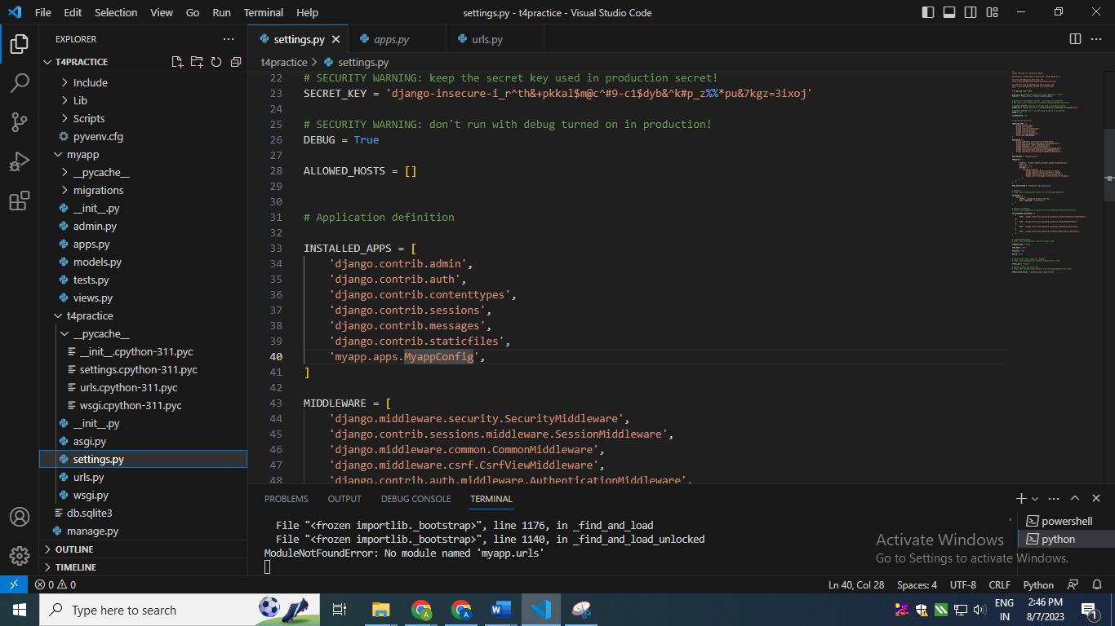
Step 13:
Go to urls.py in t4 practice and then import
from django.urls import include
Also add in urlpatterns
path('',include('myapp.urls')
